**Lab:- Network analysis by Using WireShark Tool.**

**1) Installation Process:-**

**1.Open Admin Folder you will see CS tools**

**2.Click on wire shark , Then it will start installing.**

**3.Click next next then finish.**

**2) Open Wireshark , you will see this interface. Then select your network .**

**Here my Network name is Wi-fi 2.**

**6)You will see signup page . Then signup with username:-test and Password :- test.**

**7) Now again goto wireshark and give the filtter “http” in searchbar.** 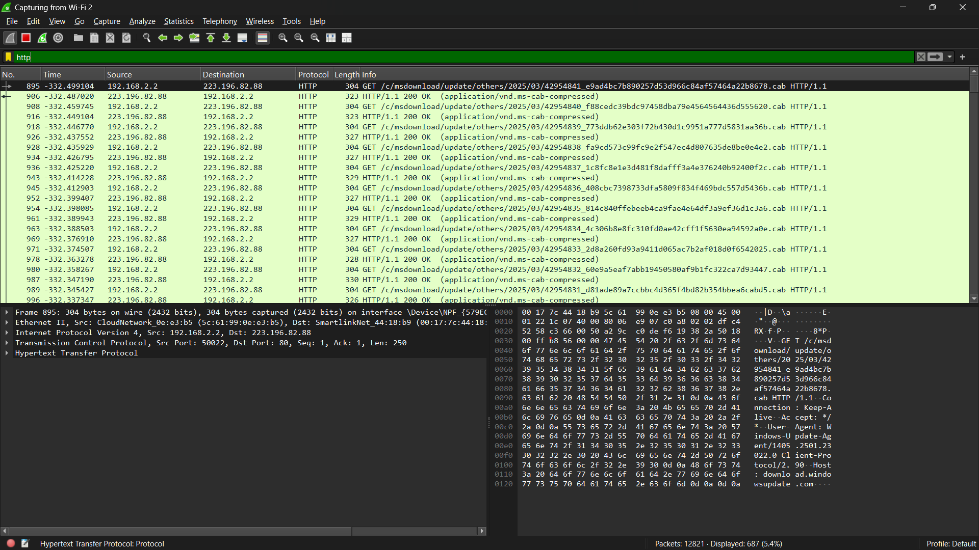

**8)You will see all http traffic . Then click on userinfo.php HTTP/1.1 Packet.**